**TutorUNI**

**Business introduction - Coreen**

The tutoring industry is currently valued at £2m (Guardian, 2016) , 40% of private tutoring was used by children in London and 1 in 10, 11-16 years old received private tutoring in England and Wales (Guardian, 2016). There seems to be a trend (Guardian 2016) towards more affluent families being able to provide their children with the option of having a private tutor to enhance and complement their education. This has alerted The Sutton Trust a charitable organisation aimed at increasing social mobility through education warns that at some point increase the inequalities of education for less affluent students (Guardian, 2016). The Sutton Trust an education charity has suggested that the Government should introduce a means-tested system to enable less advantaged children to benefit from private tutoring and close the education knowledge gap.

In order to help close this learning gap that has been created by more affluent students being able to access private tutoring, TutorUNI is an innovative connection tool that aims to solve the education need for children who may need assistance in their learning, but it is also aimed at children who do not have English as their first language.

TutorUNI’s aim is to be: ”***A tool to assist children who are struggling with their learning***”.

This can include but is not limited to language assistance, subject assistance (help with maths, reading, science etc.).] Parents can use the app to connect with a university student who can offer their child tuition at [£insert price] per hour, in the subject that the child needs assistance with.

The inspirations for the look of the TutorUNI app have come from as follows:

* Tinder: you are able to log in with various accounts, syncs your profiles and preferences. It is easy to use, you can “swipe to like”, (TutorUNI can use the log in synching aspect of Tinder for easy login for the university students. The possibility of using the swipe aspect can be used for the parent to select tutor options.)
* Amazon prime: There is the ability to go on to the website, it has a pointer system so you can see locations and has a rating system that tells you whether it is cheap or expensive. (The rating system could be used for TutorUNI for parents to see where there is a tutor available in their local vicinity and the tutor will also have a rating system attached to their pointer along with pricing).
* Mystery shopper: Is a market research app where you can pick a task via a map.
* Quick: is a home help system which matches students and elderly people. The app contains an interactive map interface which is easily accessible it also incorporates voice recognition and has a, rating system. All features which TutorUNI can adapt.

**Stakeholders - Aaron**

The table shown below identifies our key stakeholders who will help shape and equip this project for success. The roles of each stakeholder differ on which stakeholders we look to involve into the decision-making process and how to communicate, cooperate and associate with them etc.

**Internal Stakeholders**

University Students

Children

**External / Other Stakeholders**

Parents

Schools

Government / Local council

Retailers

|  |  |  |  |
| --- | --- | --- | --- |
| **Name and role of the Stakeholder** | **Benefits on projects** | **Impact on the project’s execution** | **Action requirements** |
| **University Students**    These stakeholders are considered as valuable members to this project. Acting as our primary market, individuals from this group are assigned jobs via the mobile app based on their availability and location from users. These jobs consist of one-to-one tutoring interactions with younger students in need of extra help with their school work in their homes. | · Knowledge of high academic standards can be shared and taught to children  · Flexibility/convenience with job offers and being able to offer their support instantaneously  Will give the university student valuable work experience that they would not necessarily attain if they were not using TutorUNI. | **Positive**  · Help children maximise their learning potential  · Offer the necessary assistance in areas which child is facing difficulties with  · Provide the role of a good disciplinarian in a student’s life    **Negative**  · Lack of knowledge in working with children  · Unable to connect with families to advise on child’s progress  · Not familiarised with new school curriculum reforms | · Awareness on working with children  · Liaising with parent to be well informed of child’s support program  · Take into account the awareness of child’s school curriculum reforms |
| **Children**    These are our targeted end users ranging from the ages of 11-16 (years 7-11). Those from this group will be the project's main focal point in supporting their educational needs and helping achieve improved grades towards their GCSE qualification. The users will be able to connect with academic specialists, from the field of interest, within their proximity to provide private tutoring sessions. | • Loyalty – more likely to be a source of repeat business and to recommend the service to friends and family  • Enhanced public image – helps build our brand and provides protection if there is a slip-up in overall service delivery  • More effective workforce – satisfied results of children’s education progress in school can help create a positive working environment | **Positive**  · Improved academic results  · Confidence established in their abilities of supported subjects  · Freedom from external problems and situations such as bullies, peer pressure and even boredom  **Negative**  · Learning difficulties  · Burden of extra home work along with that which is given from the school  · Students may have limited involvement in team sports and other extra-curricular activities outside of school | · Addressing and adhering to any learning difficulty child may face before tutoring begins  · Support offered will include any assignments/homework child is given from school  · Tutoring session will have to be agreed based on child and family’s availability |
| **Parents**    Considered as our secondary focal point from the children, these members will be able to connect with academic specialist via the mobile app by identifying the support that will be offered to their kids and also notice how safe their kids are with adults they do not know. | · Better tuition interaction - ability to contact parents directly would benefit from overall teaching experience  · Safeguarding security – involvement of parents would address consent needed for academic specialist to support their children. | **Positive**  · Better outcome for students’ progress  · The focus of child can be on studying  **Negative**  · Time – tutoring can absorb a substantial amount of a parent’s time  · Financial restrictions – not all families might be able to afford service if family income is already low | · Tutoring session will have to be agreed based on parent's and child’s availability  · Draw up a plan to market service at a affordable price range for all families. |
| **Schools**    This project will include the involvement of public schools in London to gain expert insight on the service and also to tailor the tutoring to the specific course materials that is offered. | · Creating excellent word of mouth promotion of services - sell services to other students who may be of interest  · Provide analysis on concepts and knowledge of what works best with certain types of students i.e. learning difficulties, attention span etc | **Positive**  · Gaining official approval from established public school  · Enhance overall tutoring experience for child  · Addressing current rules and regulations of exams and assessments  **Negative**  · Child’s learning habits/techniques may change through tutoring | · To develop and maintain child’s way of learning and understanding new study techniques through specialized handout material to explain difficult concepts using easy-to-understand ideas and examples |
| **Government / Local council**    This group’s inclusion within the project would primarily be to seek development of our business plan with financial and other supporting information. | · Building a public profile - Gain media attention which could lead to public recognition  · Free advice – providing signposting, diagnostic support and business improvement guidance | **Positive**  · Financial Support – government-backed grants  · Business support e.g. mentoring, consultancy    **Negative**  · Interference with business plan – changes in policies and procedures | · Set terms limits for all government partnering officials |
| **Retailers**    The position of this group within the project would be to attain a greater exposure of our target market and to utilise other marketing opportunities from their involvement e.g. school/loyalty vouchers. | **·**  Boost brand awareness - people will become familiar with our brand and reputation this includes local communities  · Resources available to gather feedback on current business environment/ market and use to improve/refine/develop service offer in order to remain competitive and sustainable | **Positive**  · Attract both tutors and children who will benefit from service  · Reduce promotional and advertising costs    **Negative**  **·** No control on product presentation to target market  · May offer poor customer service potentially harming our brand image | · Adopt guidelines for partners to control brand image and positioning of our core principles/standards |

*\*Stakeholder mapping diagram to follow once table above agreed with group*

**System design**

The system design would mainly focus on accessibility and have a very simple interface. The reasoning for this is our target market. One of our main target market focus is children and parents, and therefore we have to take into consideration the fact that they might not be technologically savvy. This is why the UML shows you a step by step basic guide how the system would interact with the user.

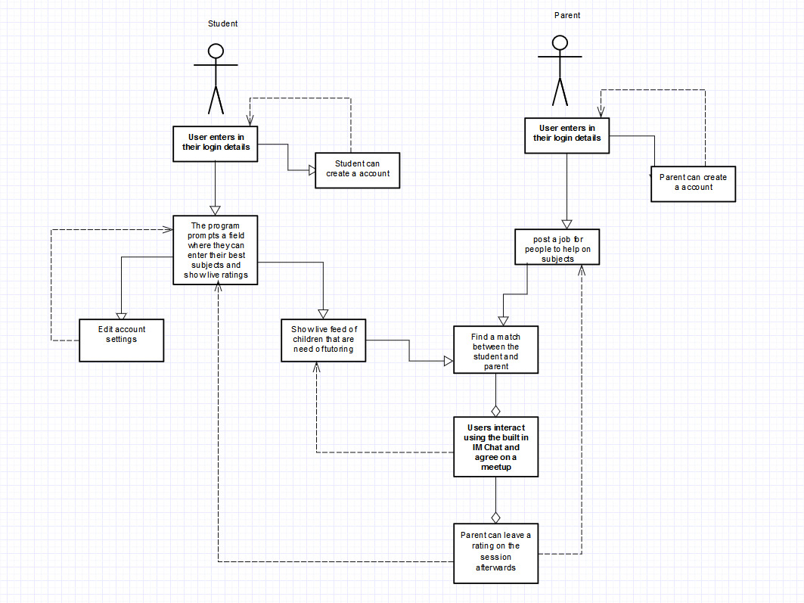

When the student enters the system, the first step is that they enter their login details, if not they can create a account which will take their university email address as well as their skills and languages Afterwards they can always check out their profiles and edit their settings this includes:

* Change of skills
* Leave a paragraph about themselves
* Add a picture of themselves
* Be able to deactivate their account
* Check if anyone has accepted their applications
* Check their previous messages

Then they can start finding matches such as who needs tutoring and start applying for the different job roles. They can also message their accepted roles and agree on meetup times and track their earnings made through the program.

**Parent**

The parent would have a different experience but it would start of very similar in a sense where they can enter in their login details and see what jobs they have posted and if they have any replies. They can start viewing the profiles of the students who have applied for their postings and decide to message one and accept them once they have agreed on one student. They can then leave feedback for their students whether the tutoring session was good or not.

The system would not 2 types of interface, one for the students which can be a little more advanced and would have more features while the other for the parents would have to be very simplistic to use. We have to consider accessibility issues like language barriers, therefore we would implement a multi language feature. We would also have a voice recognition feature where users can speak and it would try and detect the words so it makes it easier to type.

**Target market - Benji**

Our primary target market consists of two groups:

* school children; and
* University Students.

The primary group of children will consist of children aged,9 to 16 years old (year 5 to GCSE).

This primary market has been targeted as Year 5 children at this age may be preparing for their 11+ exams, alongside their SAT exams, and therefore may need added support alongside their school education.

Our secondary target user is University Students. This target market has been identified as University students may want a facility where they can earn money whilst studying whilst being able to use their knowledge to tutor children. The app will require the student to log in via their university portal to confirm authenticity. The student will then be able to find local jobs to help tutoring jobs. The student will then be able to tutor, and earn an income.

A middle target market has also been identified this group will consist of parents, schools and possibly retailers

In London alone, more than 40% of pupils have had a private tutor at some point of their school career, which usually costs on average £27 an hour. Therefore, parents may struggle to finance this additional cost, and their child may suffer academically. Therefore, parents will be able to set up a profile for their child and can find them more affordable tutoring help from local students.

Many schools have interactive learning portals, where parents can see student profiles, displaying student academic information such as reports, as well as homework. Schools could partner with our application, giving the then University ‘tutor’ access to the data, allowing them to further help the child by being able to prepare student specific learning help.

Retailers have been identified as a target market as many of the retailers run schemes supporting local businesses and ideas, where contributions are made to provide financial aid to these organisations. Waitrose for example run a community matters scheme, where after each purchase the customer is given a token, to which they can then ‘vote’ which percentage of the monthly charity allowance (£1000 for large branches, £500 for express branches) goes to which organisation. Our application could apply to one of these schemes, providing funding and support.

TutorUNI - Revenue (Zineddine Daif)

A very important aspect of every profit orientated business is to convey a reasonable income. This income can be seen as the significant measure of effectiveness of the business and this is why revenue can be seen as a main priority. TutorUNI is going to be a service were individuals (parents) can request a tutor for either their children or themselves. TutorUNI are initially focussing on University students here at goldsmiths as oppose to the rest of the UK as the application will still be in the development stage. Once the application proves that it is a solution to a particular target market’s needs we plan to give other university students around the UK the opportunity to use the application.

https://www.imf.org/external/np/pp/eng/2015/020215a.pdf

Unlike other services, the hiring of a tutor and the payment is handled entirely through the TutorUNI app rather than with the tutor. The main source of revenue coming in from this application will be the percentage we take of each transaction made in the application. TutorUni will take a 10% cut of the total revenue of each transaction made between the tutor and the parent. This transactional cut is considerably low compared to other similarly structured revenue models.

For example, a very well known company known by the name of Uber earns its revenue through a very similar process; Uber however charges a much larger cut which is taken from each transaction made between the Uber driver and the client. *“Drivers keep 75% of the total fare price for a given ride. Uber takes 25% of the fare.”* .

<http://www.alvia.com/how-much-do-uber-drivers-make/> [Date accessed?]

The reasoning behind this is the idea of keeping the cost of a tutor low for those who cannot afford standard private tuition. The cost of tuition for most parents is prohibitive however this application will give each parent the right to provide their child with a tutor regardless of their income. “35% of parents are not using a tutor because it’s too expensive” (Cooke [need a year]); there are countless articles all over the web slating high tuition fees and ultimately, something needs to be done.

University students across the UK who will be using this application will be entitled to 90% of each transaction made between themselves and the parent. The money made will be debited into their bank accounts each week. The application will be very profitable to students and to those who are struggling to find a part-time job which they can be flexible with during their studies. A survey of 2,128 students found that nearly half of students have a part-time job, including a third of students now working part-time during term time. More and more students are looking for part-time work and TutorUNI can provide an income where students can work whenever and wherever they feel.

<https://www.theguardian.com/education/2014/aug/11/students-work-part-time-employability>

**Bibliography**

Weale, S (2016) ‘Sharp rise in children receiving private tuition’, *The Guardian*. [ONLINE] Available at <https://www.theguardian.com/education/2016/sep/08/sharp-rise-in-children-receiving-private-tuition> [Accessed 23 October 2017]

[Online] / auth. Cooke Patrick // The Educator . - http://www.the-educator.org/35-of-parents-are-not-using-a-tutor-because-its-too-expensive/.